2)import java.util.Arrays;

public class Main
{
private static int[] mergeArray(int[] array1, int[] array2)
{
System.out.println("Author:P.Vamsi sita ram\nSAP ID:51834793");
int[] mergedArray = new int[array1.length + array2.length];

int a=0, b=0, c=0;

while (a < array1.length)
{
mergedArray[c] = array1[a];
a++;
c++;
}

while (b < array2.length)
{
mergedArray[c] = array2[b];
b++;
c++;
}

Arrays.sort(mergedArray);

return mergedArray;
}

public static void main(String[] args)
{
int[] array1 = new int[] {12, -7, 18, 9, 37, -1, 21};

int[] array2 = new int[] {27, 8, 71, -9, 18};

int[] mergedArray = mergeArray(array1, array2);

System.out.println("Array 1 : "+Arrays.toString(array1));

System.out.println("Array 2 : "+Arrays.toString(array2));

System.out.println("Merged Array : "+Arrays.toString(mergedArray));
}
}
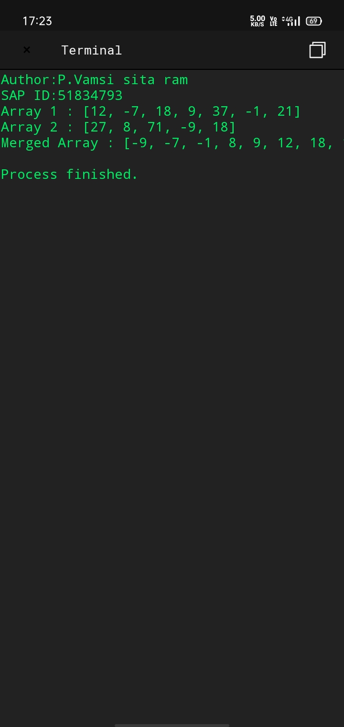
1)import java.util.Scanner;
public class AscendingOrder
{
public static void main(String[] args)
{
int n, temp;
Scanner s = new Scanner(System.in);
System.out.println("Author :G Kesava Srinivas");
System.out.print("Enter no. of elements you want in array:");
n = s.nextInt();
int a[] = new int[n];
System.out.println("Enter all the elements:");
for (int i = 0; i < n; i++)
{
a[i] = s.nextInt();
}
for (int i = 0; i < n; i++)
{
for (int j = i + 1; j < n; j++)
{
if (a[i] > a[j])
{
temp = a[i];
a[i] = a[j];
a[j] = temp;
}
}
}
System.out.print("Ascending Order:");
for (int i = 0; i < n - 1; i++)
{
System.out.print(a[i] + ",");
}
System.out.print(a[n - 1]);
}
}
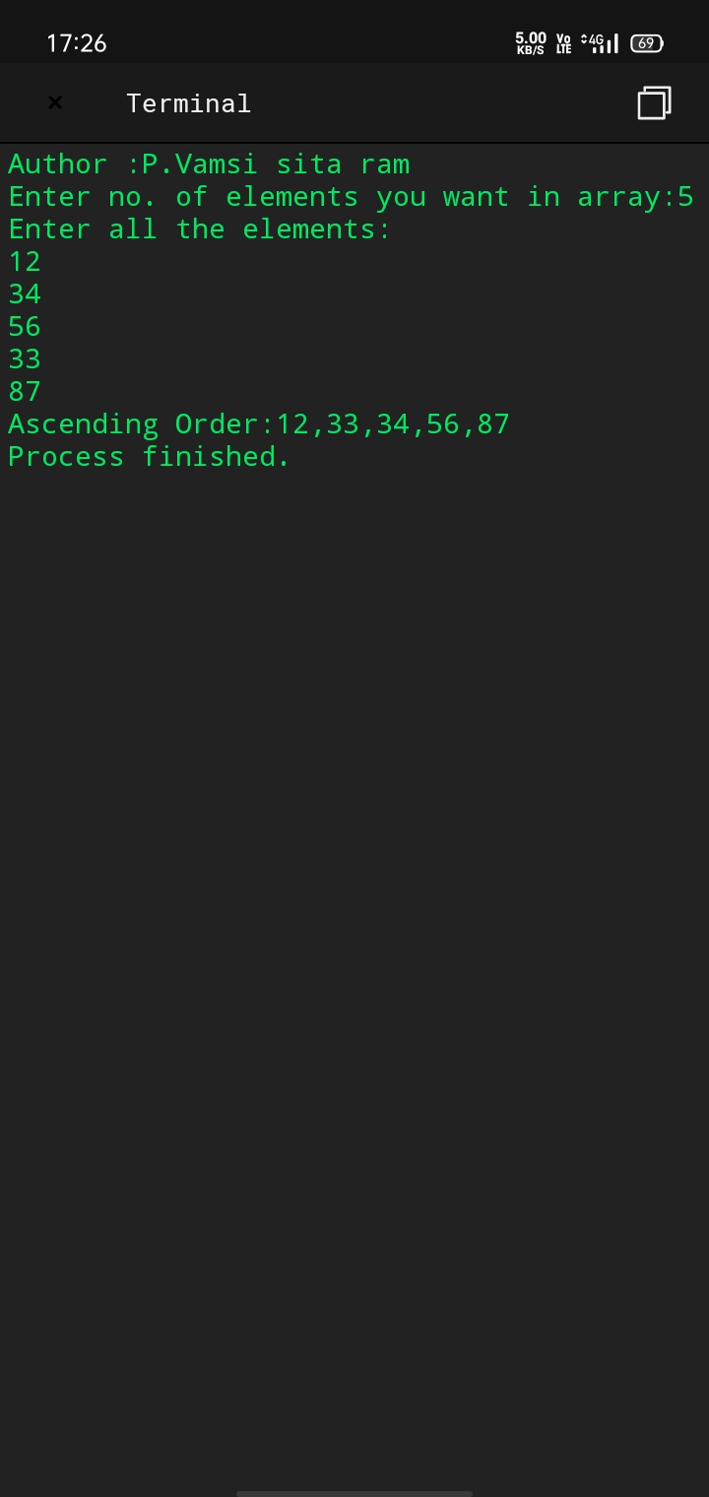

5)import java.util.Scanner;

public class Main
{

public static void main(String args[])
{
System.out.println("Author:P.Vamsi sita ram\nSAP ID:51834793");
System.out.println("Enter the string");

Scanner sc = new Scanner(System.in);

String a = sc.nextLine();

int count = 1;

for (int x = 0; x < a.length() - 1; x++)
{
if ((a.charAt(x) == ' ') && (a.charAt(x + 1) != ' '))
{
count++;

}
}

System.out.println("Number of words in a string = " + count);
}




